First and Last Name
Professor
Class
Date
Management overview module
Having understood the meaning of management as the process of planning, organizing, leading, and controlling people in an organization to effectively use the available resources to achieve organizational goals (Noe et al. 2017), and the module contributed to my personal life. I understood that I am a manager of my own and I have resources that I use daily to achieve my life goals. As a manager for my life, I always have crucial decisions to make that affect me today and the future. The management class has contributed to my personal life in that I use the resources at my disposal to make the best decisions about my daily life. The resources that I have control over include time and money, among others and they have a direct impact on me today and tomorrow. I also learned the need to be informed concerning technological trends that can contribute to my life. Finally, making the best decisions from the ones available for me has made my life organized. The cartoon artifact below motivates me to have an inclusive decision making other than being stubborn.
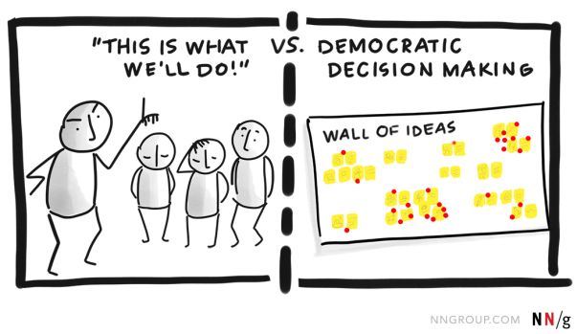
https://youtu.be/ySv-MCZm9-o
Ethics and Corporate Social Responsibility
This module taught me to have social responsibility regarding the environment. The module addresses organizations to aim at achieving profits but also ensuring that their actions do not affect the environment negatively. It reiterates that social and environmental concerns integrated into business operations. It also has an ethical inclination on organizations. The conduct of a business as a whole should ensure there is no ethical misconduct in terms of service to the customers and society (Zheng, Yadong & Stephanie 2014). From this module, I have learned to incorporate ethical behaviors in pursuance of my career as a business entrepreneur. It has reminded me to ensure that the actions of my company should not just be to reap maximum profit but to ensure that it does not affect the environment adversely. The module has also instilled in me that the conduct of my company should take into account customers' and society's satisfaction. The following artifacts have a major contribution to understanding the module. They remind us to make products brands that do not ruin the world but instead make the world a better place
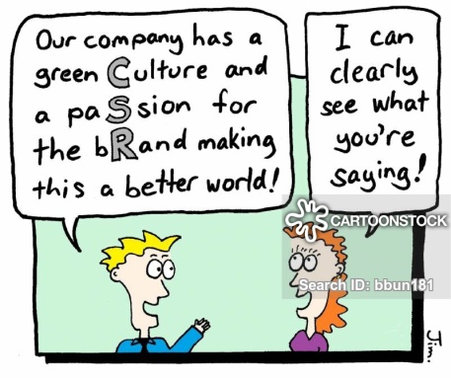
https://youtu.be/EFkSfvvAVeE
Management with Global Organizations
The module has made me learn that going global in business comes with advantages like profit maximization, access to global resources, cheap labor and many more. However, taking a business to a global level comes with some risks. Different cultural settings in different countries contribute to some of the risks. The module has also cautioned companies that they should research and plan thoroughly before entering the global business environment. The content of the module has contributed to my career in that as a business entrepreneur. I should consider expanding my business to global levels. It will allow me to reap the advantages of availed by global markets. However, I should be cautious and plan well before taking the step. The artifacts below remind organizations that before going global, there should be extensive planning and research.

https://youtu.be/m94PjbT_5GM
Planning and Decision Making
Making decisions is easy, but making the right decision is hard (Goetsch, David & Stanley 2014). The module teaches about the processes and the tools used to make the best decisions. It provides various types of decision making. I learned to be a rational decision-maker by analyzing the processes slowly and coming up with the best decision other than being an intuitive decision-maker. In pursuance of my career as a business entrepreneur, I noted the importance of using tools for decision making. One of them is using a decision tree. The module has given me a clear path to making rational and evidence-based decisions to ensure that my business flourishes. The artifacts below motivated me to have critical decision making and planning. The cartoon artifact specifically reminds me to weigh the options that are available well before making a decision.


https://youtu.be/w9Cg3_5Bfuw
Organizational Structure and Processes
The module introduced various types of organizational structures. What captured my attention is decentralizing an organization. That way, decision making is made by the managers at the lower level. I learned that when coming up with organization design, internal and external environment should be put into consideration (Osland, Kay & Marlene 2015). As a manager, the module advises that organizational culture be developed and communicated. As a business entrepreneur, the module has taught me to come up with the best organization structure and ensure communicated to my employees. The cartoon artifact below motivates me to have a simple organizational structure that serves the best interest of the organization. It brings a picture of horizontal organization structure.
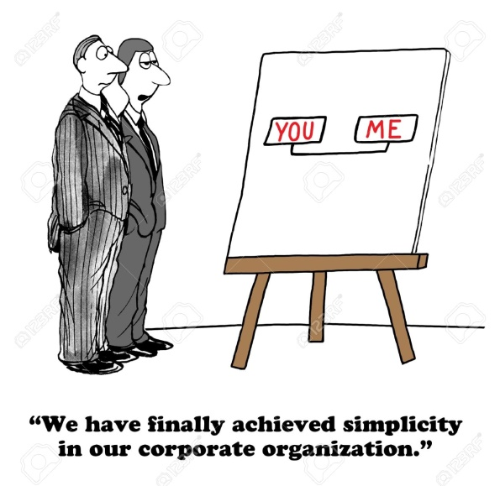
https://youtu.be/wO_-MtWejRM
Human Resource Management and Communication
In terms of communication, the module has taught me to ensure effective communication where the information is shared accurately to the right people and get the right response. The module has taught me that communication goes in hand with management in that each of the management functions requires communication. The role of management being to ensure achieving of organization goals; it does the planning, after which the plans of action get passed onto the other line managers through communication (Mondy & Joseph 2016). Through this, I learned that for management to achieve their goals, effective communication put in place. The module has contributed to my career in that, as an entrepreneur, I should ensure I should use the best human resource approach and to use effective communication to ensure corporate success. The artifact below highlights the importance of performance management as part of human resource management.

https://youtu.be/GBLTfZ0OZ1I
Leadership and motivation
The module made me have a distinction between leadership and management. While leadership establishes direction and creates followers, management entails the successful administering of all the functional parts of an organization. From this module, I have learned that employee motivation is important for organization success. By satisfying employee’s needs, they are motivated to give their best to the organization (Ahmad et al. 2014). I noted that giving the employees specific goals other than vague goals guarantees them motivation. From the module, I learned to be a leader in my personal life by being able to influence people and make followers. Being a leader means I can be able to bring people on my track. The module also gave me an insight into my career as a business entrepreneur to ensure employee motivation and also to lead by example. The artifacts below teach managers to value the potential of the other employees in an organization.

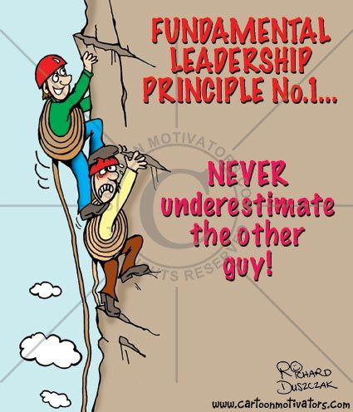
https://youtu.be/tghjgOv4mKc
Controlling Performance and Operations
The module taught me that as a manager, performance reports should always be captured to monitor progress and to measure operational success. I learned about the tools used for quality measurement. These would contribute to my career as a business entrepreneur in that I will apply them. Most importantly, I learned the use of a Gantt chart to monitor the activities in an organization. I learned that through performance reports, problems addressed in the best way. The module has contributed to building my career as a business entrepreneur. It reminds me to employ the best control and performance measures in my business. The artifacts below highlight the function of management control and performance monitoring.
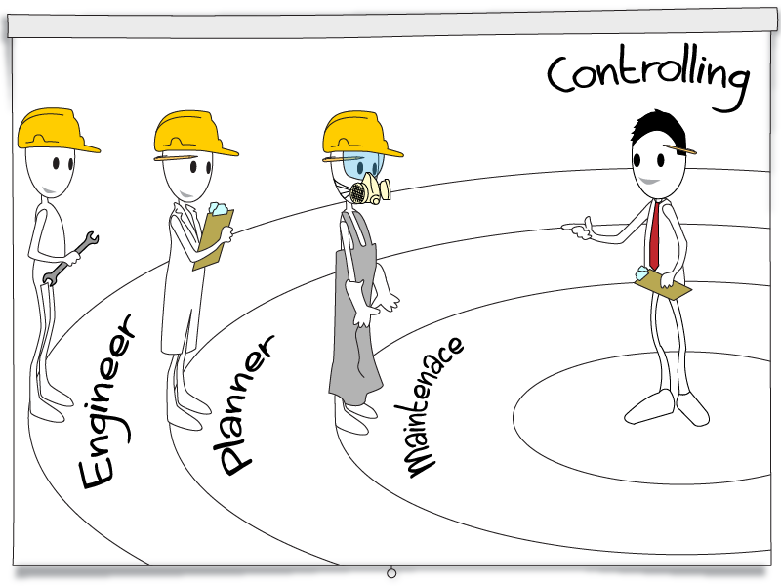
https://youtu.be/Xaf4iNOKRyU

Work Cited
Ahmad, Farid, et al. "Impact of transformational leadership on employee motivation in the telecommunication sector." Journal of management policies and practices 2.2 (2014): 11-25.
Goetsch, David L., and Stanley Davis. Quality management for organizational excellence: introduction to total quality. 2014.
Mondy, Rea, and Joseph J. Martocchio. Human resource management. Pearson, 2016.
Noe, Raymond A., et al. Human resource management: Gaining a competitive advantage. New York, NY: McGraw-Hill Education, 2017.
Osland, Joyce, Kay Devine, and Marlene Turner. "Organizational behavior." Wiley Encyclopedia of Management (2015): 1-5.
Tabory, Mala. The Multinational Force and Observers in the Sinai: Organization, Structure, and Function. Routledge, 2019.
Zheng, Qinqin, Yadong Luo, and Stephanie Lu Wang. "Moral degradation, business ethics, and corporate social responsibility in a transitional economy." Journal of Business Ethics 120.3 (2014): 405-421.

